**JAVA FUNDAMENTALS SECTION-4:**

KOLALA VAMSI

192372062

Step 1: List of Products

Here are six products that could be stored in the inventory system:

1. HP Laptop
2. Office Chair
3. LED Monitor
4. Wireless Mouse
5. Mechanical Keyboard
6. Desk Lamp

Step 2: Product Attributes Table

|  |  |  |
| --- | --- | --- |
| Attribute | Sample Data | Data Type |
| Name of the product | HP Laptop | String |
| Price | 799.99 | Double |
| Number of units in stock | 15 | Int |
| Item number | 1001 | Int |

Step 3: Create a Project ‘inventory’.

Step 4:Create the Product Class

JAVA

public class Inventory {

// Product class

public static class Product {

// Instance field declarations

private int itemNumber;

private String name;

private int unitsInStock;

private double price;

// Default constructor

public Product() {

// Initializing fields to default values

this.itemNumber = 0;

this.name = "";

this.unitsInStock = 0;

this.price = 0.0;

}

// Parameterized constructor

public Product(int number, String name, int qty, double price) {

this.itemNumber = number;

this.name = name;

this.unitsInStock = qty;

this.price = price;

}

// Getter and Setter methods

public int getItemNumber() {

return itemNumber;

}

public void setItemNumber(int itemNumber) {

this.itemNumber = itemNumber;

}

public String getName() {

return name;

}

public void setName(String name) {

this.name = name;

}

public int getUnitsInStock() {

return unitsInStock;

}

public void setUnitsInStock(int unitsInStock) {

this.unitsInStock = unitsInStock;

}

public double getPrice() {

return price;

}

public void setPrice(double price) {

this.price = price;

}

// Override toString method

@Override

public String toString() {

return "Item Number: " + itemNumber + "\nName: " + name + "\nQuantity in stock: " + unitsInStock + "\nPrice: " + price;

}

}

// ProductTester class

public static void main(String[] args) {

// Creating and initializing six Product objects

Product product1 = new Product();

Product product2 = new Product();

Product product3 = new Product(1003, "LED Monitor", 25, 149.99);

Product product4 = new Product(1004, "Wireless Mouse", 50, 29.99);

Product product5 = new Product(1005, "Mechanical Keyboard", 40, 99.99);

Product product6 = new Product(1006, "Desk Lamp", 20, 49.99);

// Displaying the details of each product to the console

System.out.println(product1);

System.out.println(product2);

System.out.println(product3);

System.out.println(product4);

System.out.println(product5);

System.out.println(product6);

}

}

OUTPUT:

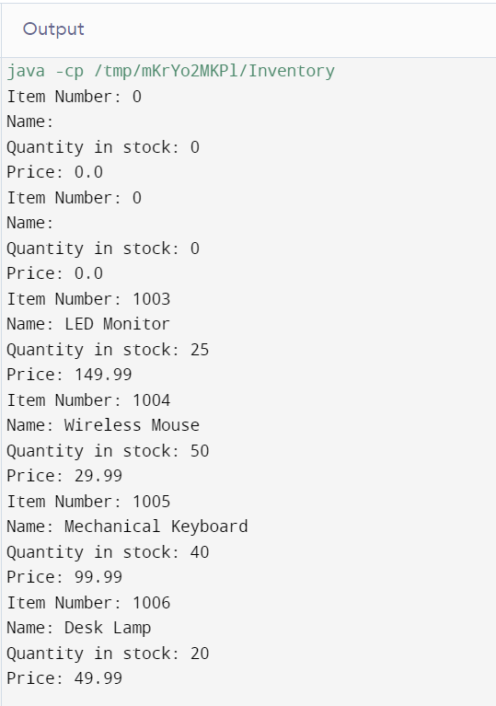

### Save the Project

Ensure that both Product.java and ProductTester.java are saved in the same directory or within the appropriate package structure if using an IDE like Eclipse or IntelliJ IDEA.

### Final Notes

This code creates an inventory system with six products, displaying their details in the console. Make sure to compile and run the ProductTester class to verify everything works as expected.